[Organization Name]

Continuity

Communications Drill
  - Drill Plan
[Month Day, Year]
The Drill Plan provides persons from participating organizations information they need to observe or participate in the drill. Some drill material is intended for the exclusive use of continuity planners, controllers, and evaluators, but players may view other materials that are necessary to their performance. All drill participants may view the Drill Plan.

This page intentionally left blank.

Contents
Drill Overview 1
General Information 2
Drill Objectives and Core Capabilities 2
Participant Roles and Responsibilities 2
Drill Assumptions and Artificialities 3
Participant Information and Guidance 4
Player Instructions 4
Scenario Information 4
Message Guidance 5
Post-Drill and Evaluation Activities 6
Participant Debriefings 6
Evaluation 6
Improvement Planning 6
Appendix A: Communications Plan A-1
Appendix B: Job Aids B-1
Appendix C: Acronyms C-1
Appendix D: Participant Feedback Form D-1

Drill Overview
Drill Name | [Organization Name] Communications Drill
Drill Date | [Month Day, Year]
Scope | This Test, Training, and Exercise (TT&E) activity is a drill to test communications capabilities through sending alert and warning notifications to [Organization Name] employees. Conduct of this drill takes place at the primary operating facility(ies), with an anticipated duration of 30 minutes/half-an-hour. Drill play is limited to [Organization Name] workgroups.
Mission Area | Protection
Core Capabilities | - Planning  - Public Information and Warning  - Operational Coordination
Objectives | 1. Validate clarity of instructions contained in notification job aids.  2a. If selecting a pre-scripted message/template: staff notified of continuity plan implementation within 5 minutes of start of drill.  2b. If writing a new message: staff notified of continuity plan implementation within 10 minutes of start of drill.  3. 75% of staff confirm receipt of message within 20 minutes.
Threat | Disruption to normal operations from confirmed continuity event.
Sponsor | Pierce County Department of Emergency Management (DEM)
Participating Organizations | - Pierce County DEM  - [Organization Name]
Point of Contact | Name:  Title:  Agency:  Address:  Phone:  Email:

General Information

Drill Objectives and Core Capabilities
Drill objectives focus on improving awareness of continuity capabilities, identifying opportunities for improvement, and achieving critical tasks as outlined in plans and/or procedures. Objectives align to core capabilities, which are distinct critical elements from the National Preparedness Goal, necessary to achieve specific mission area(s). The Continuity Planning Team selected the following drill objectives listed in Table 1.
Table 1. Drill Objectives and Associated Core Capabilities.
Drill Objective | Core Capability
1. Validate clarity of instructions contained in notification job aids. | Planning
2a. If selecting a pre-scripted message/template: staff notified of continuity plan implementation within 5 minutes of start of drill. | Public Information and Warning
2b. If writing a new message: staff notified of continuity plan implementation within 10 minutes of start of drill. | Public Information and Warning
3. 75% of staff confirm receipt of message within 20 minutes. | Operational Coordination

Participant Roles and Responsibilities
The term “participant” encompasses several distinct groups of people, not just those playing in the drill. The potential types of participants involved in the drill, and their respective roles and responsibilities, are as follows…
- Controllers: Controllers manage drill conduct, provide necessary information to players as earned, and limit certain player actions to keep drill conduct within the parameters of the drill. In addition, they monitor the overall drill timeline, prompt, or initiate specific player actions as directed, and oversee the safety of all drill participants at their assigned location.
- Evaluators: Evaluators evaluate and provide feedback on a designated functional area of the drill. Evaluators observe and document performance against established capability targets and critical tasks.
- Drill Director: The Drill Director is the person in charge of overall drill conduct, particularly the scope. The Drill Director is the primary Point of Contact (POC) from the lead sponsoring organization for the drill.
- Observers: Observers visit and view selected segments of the drill. Observers do not take part in drill conduct, nor do they perform any control or evaluation functions.
- Players: Players are the personnel who have an active role in performing their continuity personnel roles and responsibilities during the drill. Players discuss or initiate actions in response to the simulated continuity event.

Drill Assumptions and Artificialities
This drill will require certain assumptions and artificialities to conduct the drill within the time allotted, and to account for logistical limitations. Drill participants should accept that assumptions and artificialities are inherent in any drill and should not allow these considerations to negatively influence their participation.

Assumptions
Assumptions constitute the implied factual foundation for drill participation. In order for effective drill conduct, all participants should assume they exist prior to the start of the drill. The following assumptions apply to this drill…
- Drill conduct takes place in real time at all venues/locations. As such, players may receive preceding event conditions (as drill injects) prior to the start of the drill.
- The drill is conducted in a no-fault learning environment wherein capabilities, plans/procedures, systems, and processes are evaluated.
- The drill scenario is plausible, and events occur as presented.
- Drill simulation contains sufficient detail to allow players to react to information and situations as presented, as if the simulated incident were real.
- Real world emergencies take priority over drill events; in such instances, participating organizations may pause the drill at their venue.

Artificialities
To provide all participants an opportunity to meet specific drill objectives within the allotted timeframe AND so that drill conduct does not impede capabilities, certain artificialities (i.e., would not apply to actual continuity operations) are designed into the drill. The following artificialities apply to this drill…
- Players will use routine, in-place, communication systems.
- The need to maintain capabilities for responding to actual emergencies may exempt certain notification systems from use.
- To avoid the drill being mistaken for an actual continuity event, the below precautions will be observed…
- All participants must begin and end all verbal communications with the phrase: “This is a test.”
- All documents/products (e.g., forms, maps, etc.) must be clearly labeled “TEST.”
- Drill communication is limited to participating organizations: players will send communications to [Organization Name] and the Pierce County DEM Duty Officer ONLY.

Participant Information and Guidance

Player Instructions
Players should follow the following guidelines before, during, and after drill conduct to ensure a safe and effective drill. In addition to these general rules, the host organization of a participating venue may have additional requirements for players to observe during drill conduct.

Before the Drill
- Attend pre-briefings for drill players.
- Review appropriate organizational plans, procedures, and drill support documents (such as this plan).

During the Drill
- Drill conduct begins concurrently with the Great ShakeOut Drill.
- Working individually:
- Review the scenario, imagine this occurring at your organization.
- Using PC WARN, send a notification message to the staff of your organization.
- [Optional instructions for a communications drill include opportunities to test evacuation procedures, personnel accountability, or staff checking-in with their out-of-area contact].
- ALL communications during drill conduct—such as verbal, written, radio, telephone, and email—must begin and end with the statement: “This is a test.”

After the Drill
- Participate in the post-drill debriefing—AKA “Hot Wash”—with the drill sponsor.
- Complete the Participant Feedback Form. This form allows you to comment candidly on the effectiveness of plans, the organization, or equipment observed during drill conduct, as well as drill design and development.
- If a hardcopy form is used at your venue, provide the completed form to a controller/evaluator.
- Provide any hardcopies of documents or material generated during the drill to a controller/evaluator at the conclusion of the Hot Wash.
- Restore your workstation and/or equipment to a ready condition (i.e., as it was prior to the drill).

Scenario Information
A devastating earthquake has just occurred in our region. Available information suggests there is considerable damage to facilities and infrastructure. Normal operations are severely disrupted, with initial indications for restoration lasting up to 30 days/one month. Your organization head has implemented the continuity plan, and requested you notify all employees.

Message Guidance
All alert and warning notifications—regardless of the medium—should conform to the general principles of effective communication: clarity, specificity, and consistency are crucially important during a crisis. Reference the following four guidelines when developing messages for alert and warning:
- Be short and to the point: in as few words as possible, place the critical information at the forefront. Word the message precisely, making every word count, while avoiding jargon and acronyms. Your audience should know exactly what to do within seconds of receiving and reading the message.
- Be specific with directions, but general with information: when a continuity event occurs, you may not have detailed and accurate information readily available. In fact, the information you do have could only be speculation. Your initial message needs to prompt your coworkers to act without potentially confusing them with additional—and unnecessary—details.
- Use timestamps: this simple tool has significant worth when informing others by message. A timestamp confirms that an event is currently happening for those receiving the message immediately, or that the message could be outdated for those receiving it at a later time. Personnel aware of what information is the most recent can avoid creating confusion when implementing the continuity plan.
- Provide sources of additional information: your organization should have a website or hotline that anyone can check at any given time to learn the latest details during a continuity event. These tools must be easily accessible, and everyone in the organization should already know where to find these sources. This empowers personnel within your organization to check for the most up-to-date information, and also learn everything they need to know at any given time.

Example Message
The following is a brief example of message content for both the initial communication of a continuity event and to account for all employees.
Message Title: [Organization Name] Test Notification for Continuity Event.
Message Body: ***THIS IS A TEST*** A continuity event has occurred that is disrupting normal operations at [address]. Continuity plan has been implemented and non-essential functions are suspended. Please respond to enclosed poll for personnel accountability. ***THIS IS A TEST***
- Text Response 1: I received message and am in the office.
- Text Response 2: I received message and am out of the office.

Using a Template
Consider developing subject-specific message templates that incorporate pre-approved language. Successfully using pre-scripted messages can:
- Help prevent errors or omissions;
- Increase the speed of, and reduce delays in, issuing alerts and warning notifications; and,
- Allow for more accurate language translation in advance.

Post-Drill and Evaluation Activities

Participant Debriefings
Post-drill debriefings with all participants aim to collect sufficient relevant data to support effective evaluation and improvement planning.

Hot Wash
At the conclusion of drill conduct, venue controllers facilitate a “Hot Wash” to allow players the opportunity to discuss any best practices and areas for improvement, and evaluators the opportunity to seek clarification regarding player actions and decision-making processes. All participants, with the potential exception of observers, should attend. A Hot Wash should not exceed 30 minutes.

Participant Feedback Forms
Participant Feedback Forms provide players with the opportunity to comment candidly on drill activities and drill design. Participant Feedback Forms can be either hardcopy or electronic, and should be received at the conclusion of a Hot Wash.

Evaluation
The evaluation is the culmination of a TT&E activity. Preparing for the evaluation occurs throughout the drill planning process, beginning when continuity planers first meet to establish drill objectives and initiate scenario design. An effective evaluation assesses performance against evaluation criteria, while identifying and documenting strengths and/or areas for improvement observed during drill conduct.

After-Action Report
The end-result of drill evaluation is the After-Action Report (AAR). Through root cause analysis, an AAR validates the strengths and areas for improvement that evaluators observed during drill conduct. The drill sponsor develops and distributes the AAR.

Improvement Planning
Improvement planning is the process by which the observations recorded in the AAR are resolved through development of concrete corrective actions, which are prioritized and tracked as a part of a continuous corrective action program.

After Action Meeting/Conference
The After-Action Meeting/Conference is a meeting held with decision-makers from the participating organization(s) to review the AAR. The facilitator debriefs attendees on the evaluation of the drill, and the identification and analyses of any areas for improvement. It is at this meeting that the corrective action process for the participating organization(s) begins. Decision-makers for the primary responsible organization(s) determine a reasonable timeframe to correct any issues identified, and assign an organization Point of Contact (POC) to oversee the corrective action to a successful resolution.

Improvement Plan
An IP identifies the corrective actions, for each area for improvement and aligned core capability, agreed upon at After Action Meeting/Conference. Each corrective action is assigned a primary responsible organization, organization POC, a start date, and a target completion date.

Appendix A: Communications Plan
All written and recorded communications will start and end with the statement “THIS IS A TEST.”
Player Communications
Drill communications do not interfere with real-world emergency communications. Players use routine organization communications systems. Additional communication assets may be made available as the drill progresses. Each venue or organization coordinates its internal communication networks and channels.
Controller Communications
The principal methods of information transfer for controllers during the drill are verbal guidance/instruction and e-mail.
Communications Check
Before the drill, controllers conduct a communications check with all interfacing communications systems to ensure redundancy and uninterrupted flow of control information.
Player Briefing
Controllers may be required to provide scenario details to participants to begin drill play. Technical handouts or other materials also may be provided to orient players with the drill.
Public Affairs
The sponsor organization and participating organizations are responsible for coordinating and disseminating public information before the drill. Each venue should follow internal procedures.

Appendix B: Job Aids
TITLE: | PC WARN User Guide for Pierce County Department Continuity Coordinators
GENERAL INFORMATION:
PC WARN is interfaced via the Everbridge Mass Notification platform. It is used to send notifications to department staff.

Use of PC WARN notifications shall only occur at the direction of the Organization Head.

Overview
PC WARN notifications may be launched for circumstances that range from critical life and death emergent situations to simple informational notices for specified groups in the contact database. Information sent using PC WARN can be delivered to contacts across multiple platforms (e.g., text/voice on cellular device, e-mail, voice on landline, text on pager, fax). The severity of an incident will determine the delivery methods.

Types of Messages
- Critical: Any incident occurring that is an imminent threat to life and property. These messages should be sent to all groups who may be affected and who may respond to the incident. Select all notification paths (i.e., e-mail, SMS text, landline, cellular phone call, pager, fax) to send these messages. It may be necessary to follow up using alternative communication methods.
- Emergency Notification: An incident that is not life threatening but may have significant impact on a population or community. (e.g., Road Closures or Weather Notifications that will affect the day to day activities of a municipality or school). These messages should be sent as text only (i.e., e-mail, SMS text, pager, fax) unless a directed otherwise.
- General or Informational: These messages should be sent to groups or jurisdictions as appropriate. Select only e-mail for these types of messages.

All continuity event-related PC WARN messages should be sent to ALL department staff.
PROCEDURES:
Login to the Everbridge Web Site: https://manager.everbridge.net/

- Select Organization (top dark gray ribbon/bar) “Pierce County - PC WARN.”
- Select “Notifications” (lighter gray ribbon/bar immediately below).
- Select “New Notification” (blue-outlined button).
- If the message requires an attachment (such as a map) of any file type, the Adobe Flash Player must be downloaded first (see Fig. 1). If message content is added first, and the Adobe Flash Player is downloaded after, all message content will be lost and need to be reentered.
- Add message Title, message Body, and voice recording (if needed). If the message is only being sent using the e-mail delivery method, it is not necessary to click “Include separate message for e-mail notifications;” simply enter the text in the “Message Body” box.
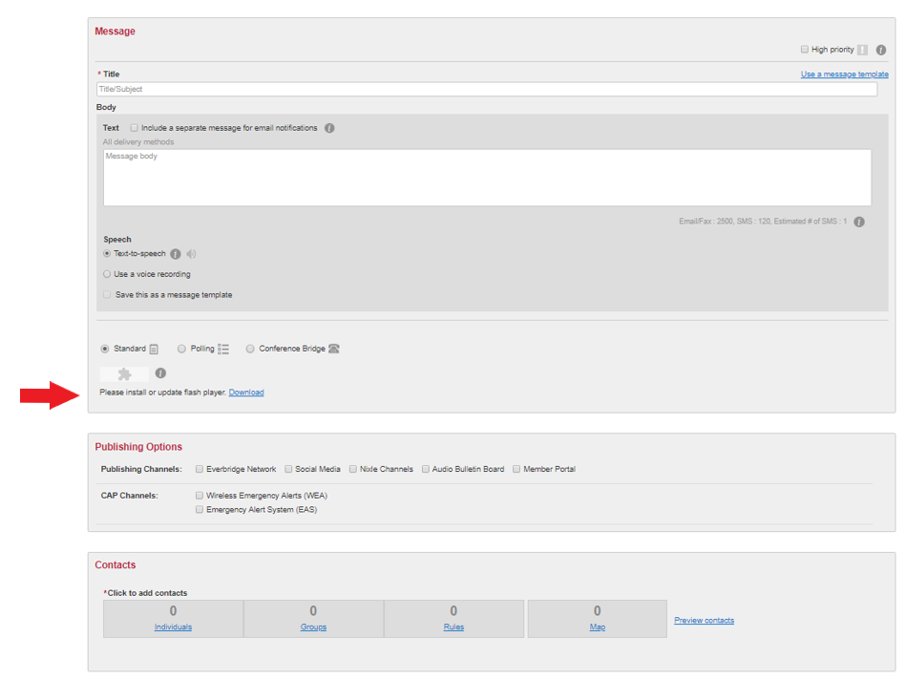
- Title the Message.
Figure 1. Flash Player Installation for Email Attachments
- Enter the Text of the Mes-sage.
- Attach files, if needed.
- Select Stan-dard, Polling, or Conference Bridge.
- Select Contacts.
- Select the Indi-viduals and/or Groups that will receive the mes-sage.
- For Individuals, search either by First and/or Last Name, or use Advanced Search to select Contacts based upon specific information such as Record Type or Location.
- Select applicable Group(s) in Contacts to receive the message.
- Click “OK” when finished selecting recipients.
- Modify the following Settings as needed.
  - Caller ID and Sender E-mail: Consult with Organization Head
  - Specify if the message will be sent with a confirmation.
  - Choose the delivery method(s).
  - Specify the broadcast Duration (normally 1 hour is sufficient).
  - Specify the Contact Cycles.
  - Specify the Intervals between contact paths and cycles (set to 2 minutes).
  - Specify Voice Mail preference if the system reaches voicemail (select message only).
- Send the message.

Appendix C: Acronyms
AAR–IP After-Action Report–Improvement Plan
CAP Corrective Action Program
COG Continuity of Government
COOP Continuity of Operations
DEM [Pierce County] Department of Emergency Management
EAS Emergency Alert System
EMAP Emergency Management Accreditation Program
GETS Government Emergency Telecommunications Service
HSEEP Homeland Security Exercise and Evaluation Program
HR Human Resources
IPAWS Integrated Public Alert and Warning System
IT Information Technology
MAA Mutual Aid Agreement
MOA/MOU Memorandum of Agreement/Memorandum of Understanding
NAWAS National Warning System
NGO Non-Governmental Organization
NOAA National Oceanic and Atmospheric Administration
NWS National Weather Service
PNP Private Nonprofit
PSAP Public Safety Answering Point
PSTN Public Switched Telephone Network
SMS Short Message Service
THIRA Threat and Hazard Identification and Risk Assessment
TSP Telecommunications Service Priority
TT&E Test, Training, and Exercise
USGS United States Geological Survey
WEA Wireless Emergency Alerts
WPS Wireless Priority Service

Appendix D: Participant Feedback Form
Please use this form to provide your feedback. Your observations, comments, and input are appreciated, and provide valuable insight that better prepares your department for continuity events. Please keep your feedback concise, specific, and constructive. Contact information is for potential follow-up to clarify or add context to comments received.
Name: |  |  |  | Agency:
Email:
Role: | Player | Controller | Observer | Evaluator
Part I: Observations from Drill Conduct
- Based on today’s activities and the tasks performed, please list up to three strengths for reinforce and maintain:

- Based on today’s activities and the tasks performed, please list up to three areas for improvement for corrective action:

- Please list the policies, plans, and procedures that should be reviewed, revised, or developed. Indicate the priority level for each (high–medium–low).
Item for Review | Priority
Part II: Additional Comments
What changes would you make to this drill? Please provide any recommendations on how this exercise or future drills could be improved or enhanced.

